Drafted by S. Nickovic (June 2016)

South-East European Consortium for Operational weather Prediction (SEECOP)
Modelling Concepts and Plan of Activities for 2016-2021

- Introduction
The establishment of the South-East European Consortium for Operational weather Prediction Consortium (SEECOP) has been initiated by the South-East European Virtual Climate Change Center (SEEVCCC) partners who put into force the SEECOP Agreement which specifies the conditions for the collaboration between the SEECOP Members.
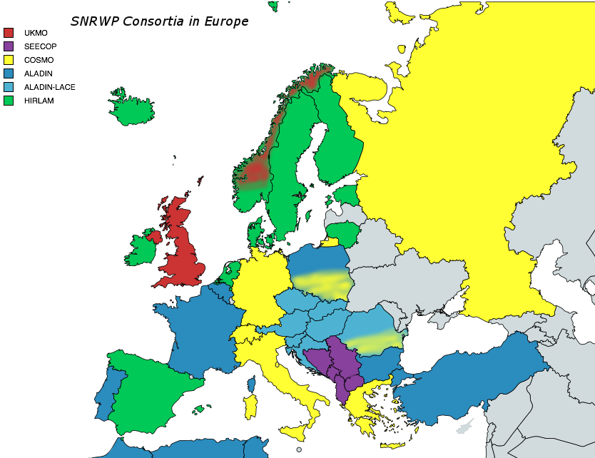
SEECOP consortium (colored in pink)

The SEECOP objective is to establish collaboration between Country Members adressed to providing a state-of-the-art NWP products based on the application of the Nonhydrostatic Multiscale Model on B-Grid (NMMB model (Janjic 2009)) of NCEP for both research and development activities; in addition, to use NMMB products as drivers for operational of environmental forecasts of different kinds (aerosol, hydrology, etc). Within SEECOP, Members agreed to share the available expertise, data, modelling and technical resources in NWP; to therefore reduce overlapping in NWP activities in the region; to organize training for use of the NMMB system and related applications; to enhance the operability of NWP.
- Seamless Concept for Prediction of Weather and Climate
SEECOP follows the concept of so-called seamless weather and climate prediction - a trend in numerical weather prediction (NWP) and climate modelling communities to use generally same atmospheric modelling systems for scales from days to seasons and beyond, which are coupled with other Earth system components such as: soil, chemical composition, oceans, land-surface, and surface hydrology.
According to the World Climate Research Program (WCRP) report on the seamless concept (Shukla, 2009), there is no scientific basis to draw artificial boundaries between meso-scale prediction, synoptic scale prediction, seasonal prediction, and decadal prediction. However, practical considerations of computing and of model complexity may require different prediction systems for different time scales. The simulation and prediction of meso-scale systems, synoptic scale disturbances, intra-seasonal, seasonal and inter-annual variations are intimately linked, and therefore, it is suggested that future research on prediction of weather and climate be carried out in a unified framework. A fundamental principle of seamless prediction is that the coupled atmosphere-ocean-land-aerosol-hydrology system exhibits a wide range of dynamical, physical, biological and chemical interactions involving a continuum of spatial and temporal variability of the overall system. Early ideas on needs to integrate the Earth system components to interact through different feedback mechanisms has been advocated by Nickovic (2002), who suggested two-way coupling within a seamless Earth system model in order to increase quality of forecasts.
In order to address the question of predictability in terms of the statistics of high impact local weather events it is required that the models used for seasonal prediction also resolve and simulate the local weather events. It is therefore essential that the models for predicting daily, weekly, monthly and seasonal variation be unified. In other words, very high-resolution models without parameterizations of deep moist convection must be extended at least up to a season to predict the statistics of high impact weather events within a season. It can be conjectured that since parameterizations of moist convection in coarse-resolution models is the main source of uncertainty in simulation and predicting seasonal means, models that can explicitly simulate organized could systems with moist convection will enhance the predictability of weekly and monthly averages during a season.
SEEVCCC has been formed the seamless prediction principle and it has been mainly conducted by the modelling experts from the RHMSS, the University of Belgrade and scientists from the Serbian diaspora designed an Earth system model structure by integrating a variety of NCEP atmospheric models (including NMMB) and models for the aerosol transport, hydrology dynamics, soil processes and ocean circulation (Janjic et al, 2001; Djurdjevic and Rajkovic, 2008; Nickovic et al, 2001; Pejanovic et al, 2011). A natural extension of SEEVCCC was the launching of SEECOP in order to exploiting the existing modelling expertise in the SEE region and already developed software and expertise infrastructure. Following suggestions to use unfired atmospheric models (one model for all scales, from local to global) in the seamless system (...The simulation and prediction of meso-scale systems, synoptic scale disturbances, intra-seasonal, seasonal and inter-annual variations are intimately linked, and therefore, it is suggested that future research on prediction of weather and climate be carried out in a unified framework...(Shukla, 2009)) it was a natural choice to accept the NMMB model (Janjic 2009) for both SEECOP and SEEVCCC activities. Namely, NMMB has been designed so that the same software code could be used either over a limited or global geographic domain, and to use the on/off switcher for hydrostatic or nonhydrostatic executions (see APPENDIX).
- Current NWP activities in SEECOP
Most of the SEECOP partners already has experience in NWP modelling, which is important basis and a starting point for collaborating in the Consortium. The experiences ranges from:
- using and interpreting ready NWP products from external sources,
- running different NWP models (mostly NCEP or NCAR WRF-based (ARW and NMM) models),
- implementation of the newest generation of the NCEP NWP system - NMME and NMMB
- developing new applications based on the NWP models.
Current operational NWP activities of Members
Provide brief description of your current operational NWP and related activities (max 2 pages): present which are operating NWP system(s), operational or experimental; basic setup elements (resolution, domain (show map), execution frequency, initial/boundary conditions, nesting if any), computer resources

Albania

the Federation of Bosnia and Herzegovina (Bosnia and Herzegovina)

the Former Yugoslav Republic of Macedonia

the Republic of Srpska (Bosnia and Herzegovina),

Montenegro

Serbia

Models used operationally for NWP
(Bojan Kasic, Analist for data assimilation, NWP department)
NNMB (Janjic and Gall, 2012.) global:
240h forecasting period, initial conditions – 120h forecasting period, initial conditions – GFS analyses 00 and 12 UTC, horizontal resolution 0.47*0.33 degrees, 64 sigma-p vertical levels, model top is at 10mb, time step 80 sec, global domain, finite differences method with application of spherical filters around poles, non hydrostatic, geog data resolution 2m, NCEP's Gravity Wave Drag taken from GFS model, 2nd order diffusion in horizontal and vertical, PBL is Mellor-Jamada-Janjic with NOAH land surface sheme, GFDL shortwave and long-wave radiation schemes, Betts-Miller-Janjic convection scheme (table 4.2.2.1).
ETA:
120h forecasting period, initial and boundary conditions – DWD model, 00 and 12 UTC, horizontal resolution 26km, vertical resolution 32η layers, Euro-Atlantic domain 24N-70N and 40W-55E, hydrostatic.
WRF-NMM (Janjic et. all, 2014.):
192h forecasting period, initial and boundary conditions – GFS model 00 and 12 UTC, horizontal resolution 10km, vertical resolution 38 sigma-p levels, model top 50mb time step 30 sec, Euro-Atlantic domain 20W-35E and 32N-63N, non hydrostatic, geog data resolution 30s, gravity wave drag off, 2nd order diffusion in horizontal and vertical, PBL is Mellor-Jamada-Janjic with NOAH land surface sheme, GFDL shortwave and long-wave radiation schemes, Betts-Miller-Janjic convection scheme.

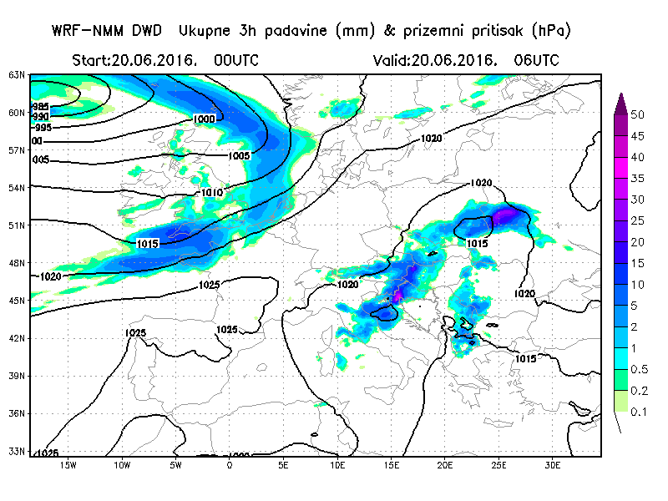
Illustration : WRF-NMM
WRF-NMM:
120h forecasting period, initial and boundary conditions – DWD model 00 and 12 UTC, horizontal resolution 10km, vertical resolution 38 sigma-p levels, model top 50, time step 30 sec, Euro-Atlantic domain, 20W-35E and 32N-63N, non hydrostatic, geog data resolution 30s, gravity wave drag off, 2nd order diffusion in horizontal and vertical, PBL is Mellor-Jamada-Janjic with NOAH land surface scheme, GFDL shortwave and long-wave radiation schemes, Betts-Miller-Janjic convection scheme.
WRF-NMM:
72h forecasting period, initial and boundary conditions – ECMWF, IFS 00 and 12 UTC, horizontal resolution 4 km, vertical resolution 45 sigma-p layers,model top 50mb, time step 8 sec, Balkan-Adriatic domain, 40N-48N and 11.5E-26E, non hydrostatic, geog data resolution 30s, gravity wave drag off, 2nd order diffusion in horizontal and vertical, PBL is Mellor-Jamada-Janjic with NOAH land surface scheme, GFDL shortwave and long-wave radiation schemes, Betts-Miller-Janjic convection scheme.
NMMB regional:
120h forecasting period, initial and boundary conditions – NMMB-global (RHMS), initialized at 00 and 12 UTC, horizontal resolution 12 km, 64 sigma-p vertical levels, model top 10mb, timestep 20 sec, Euro-Atlantic domain 20W-35E and 32N-67N, non hydrostatic, geog data resolution 1m, gravity wave drag on, 2nd order diffusion in horizontal and vertical, PBL is Mellor-Jamada-Janjic with LISS land surface scheme, RRTM shortwave and long-wave radiation schemes, Betts-Miller-Janjic convection scheme.
NMMB nested :
72h forecasting period, initial and boundary conditions – on line nested into NMMB-regional; model starts at 00 and 12 UTC, horizontal resolution 4 km, 64 sigma-p vertical levels, model top 10mb, timestep 8 sec, Balkan-Adriatic domain, 40N-48N and 11.5E-26E, non hydrostatic, geog data resolution 30s, gravity wave drag off, 2nd order diffusion in horizontal and vertical, PBL is Mellor-Jamada-Janjic with LISS land surface sheme, RRTM shortwave and long-wave radiation schemes, without convective parametrization.
NMMB 4km:
72h forecasting period, initial and boundary conditions – ECMWF, model starts at 00 and 12 UTC, horizontal resolution 4 km, 64 sigma-p vertical levels, model top 10mb, timestep 8 sec, Balkan-Mediteranian domain, 36N-50N and 3E-31E, non hydrostatic, geog data resolution 30s, gravity wave drag off, 2nd order diffusion in horizontal and vertical, PBL is Mellor-Jamada-Janjic with LISS land surface sheme, RRTM shortwave and long-wave radiation schemes, without convective parametrization. This model runs inside of EC-FLOW on ECMWF's Cray supercomputer.
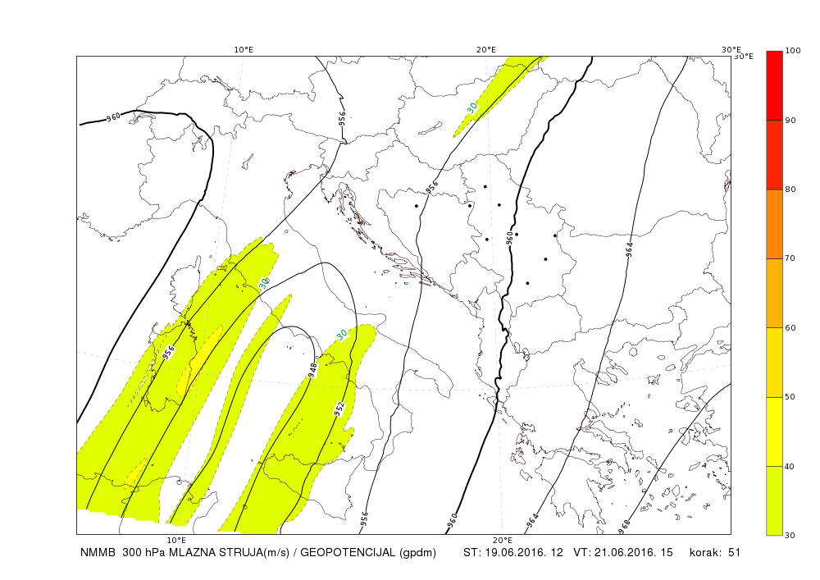
Illustration : NMMB 4km
Research and experimental activities in NWP
One version of NMMB regional with data assimilation is running in pre-operational mode in NWP department of RHMSS. Model setup is described above as NMMB regional. Data assimilation system is hybrid 3D Ensemble Variational (3D-EnVar). 3D-EnVar consist of LETKF (Local Ensemble Transform Kalman Filter), Hunt et. All 2007. , 3D-Var, and GSI (Grid Statistical Interpolation) observational operators. The LETKF works with 51 ensemble members, NMMB reg, with 12 km resolution and with multi physics within ensemble members. EnVar uses LETKF-NMMB ensemble to calculate background error in order to produce deterministic analysis on the same resolution. Boundary conditions for the ensemble members are from ECMWF's global ensemble and for deterministic model from ECMWF's IFS model. Currently, new analysis is performed on every 6h, at 00, 06, 12, 18 UTC using 3 hours assimilation window. Forecast 3 days in advance is run from those analysis 4 times a day. Data assimilated include: upper-air soundings from radiosondes and dropsondes (ADPUPA), surface stations (ADPSFC), ships and buoys (SFCSHIP), aircrafts (AIRCFT), and various types of remote sensing of winds (PROFLR, VADWND, SATWND, SPSSMI, QKSWND); GPS radio occulation; and radiances from SEVIRI – m10; AMSUA – metop-a, metop-b, aqua, nnp, n15, n18, n19; AIRS – aqua; IASI – metop-a, metop-b; HIRIS4 – metop-a, metop-b, nnp, n19; CRIS – nnp; ATMS - nnp, and MHS – metop-a, metop-b, nnp, n18, n19 satellite sensors. The System is running in pre-operational mode since beginning of February, 2016. and some of the initial results have been shown in (Kasic 2016).
Another version of NMMB (described above as NMMB 4km) with data assimilation has been tested for a single test case. Data assimilation system is the same as for NMMB regional with main difference in analysis been produce on every 3h.
On-line nesting of NMMB with 1.33 km resolution has been tested inside of operational NMMB 4km described above.

Computational resources:
HPC Cluster-“new“: 32 Blade servers BL 2x220c generation 7, 2 Blade C7000 enclosure
HPC Cluster-“old“: 16 HP Blade servers BL 2x220c generation 5 and 16 Blade servers BL 2x220c generation 6
For 2016. RHMSS has dedicated 106,199 KSBU at Europen Center fo Medium Weather Prediction's Cray supercomputer as full member.

Parameterization of ice nuclei number due to dust
RHMSS has developed a coupled real-time forecasting atmosphere-dust forecasting system (Nickovic et al., 2016), which predicts ice nuclei number (${ n}_{IN}$) due to dust aerosol, as an online model variable. ${ n}_{IN}$ is the major external parameter in cold cloud heterogeneous ice nucleation microphysics schemes which is currently used either as a pre-specified constant or as a climatology value.
This development is a result of the scientific evidence on dominant role of dust in cold cloud formation (Cziczo, 2013; Atkinson et al, 2014) which motivated a number of research groups to link cloud microphysics schemes with parameterizations of dust-affected $n_{IN}$ in atmospheric models (DeMott et al 2015; Niemand et al. 2012; Steinke et al. 2015).
Such new component represents a step towards operational cold clouds prediction and associated precipitation. To our knowledge, this is the first time that all ingredients needed for cold cloud formation by dust are predicted in operational forecasting mode within one modeling system. For this study, immersion and deposition modes of freezing are assumed to be dominant for ice formation process. Significant correlation between model and observed conditions for icing are achieved.
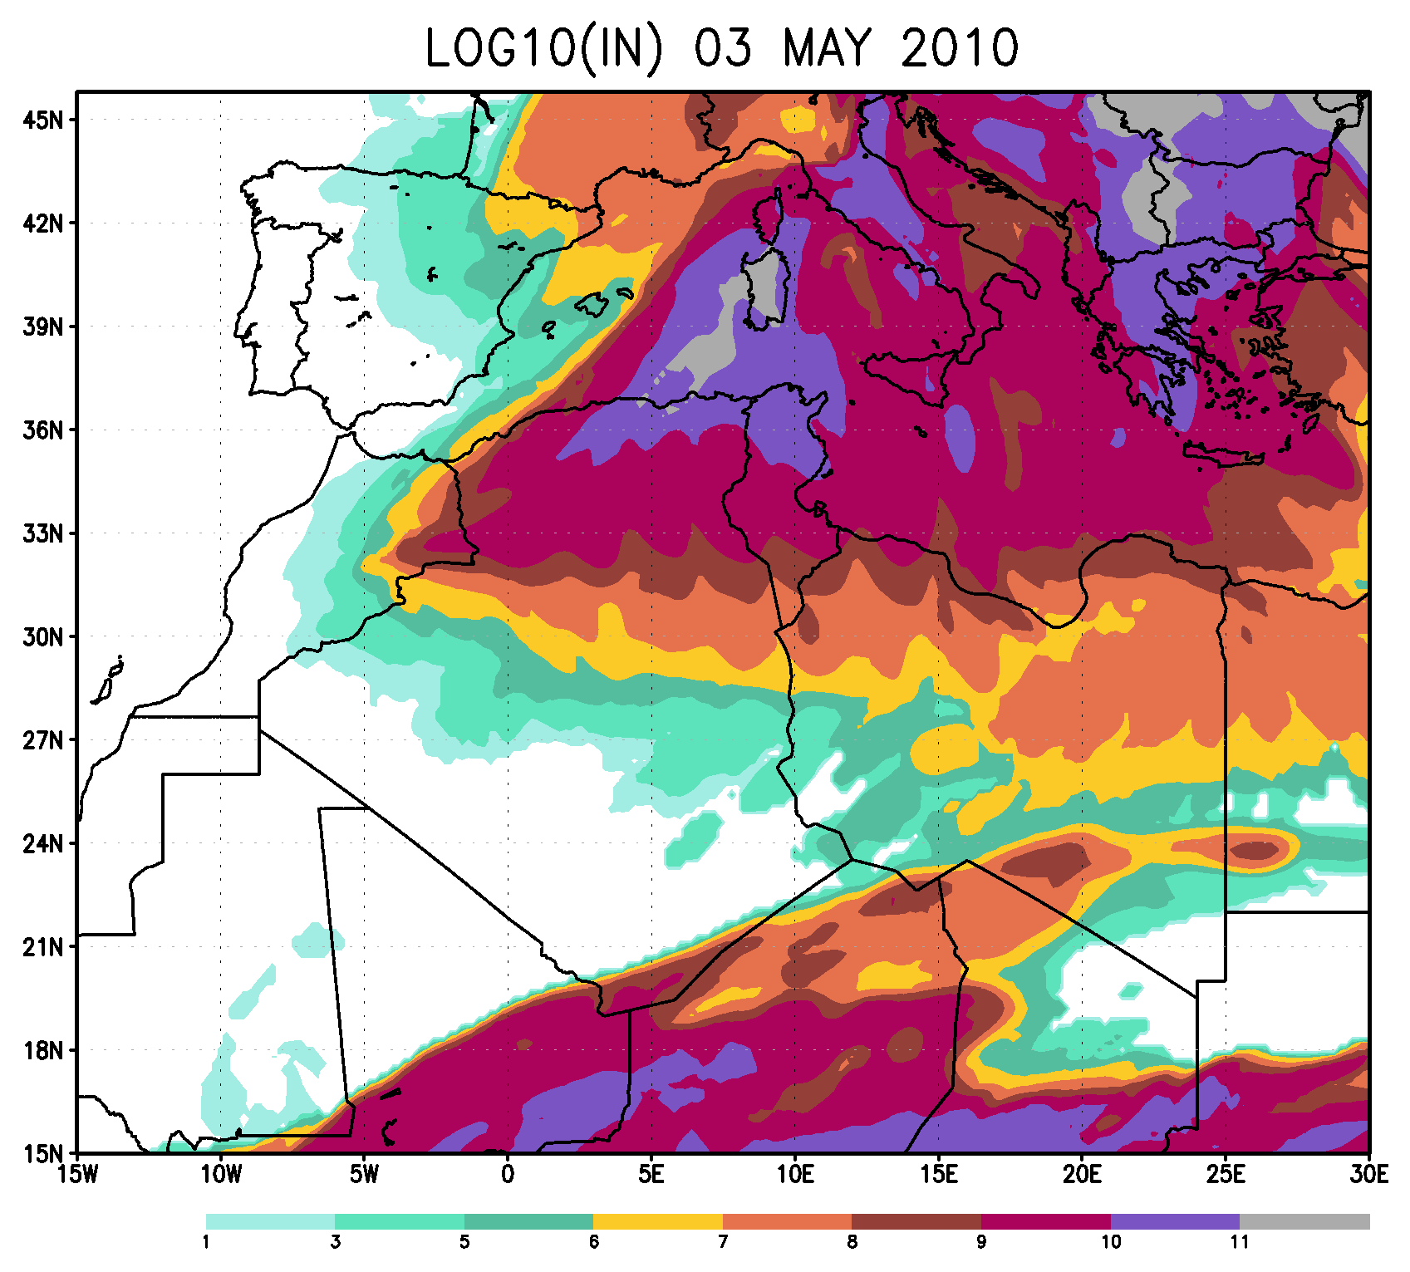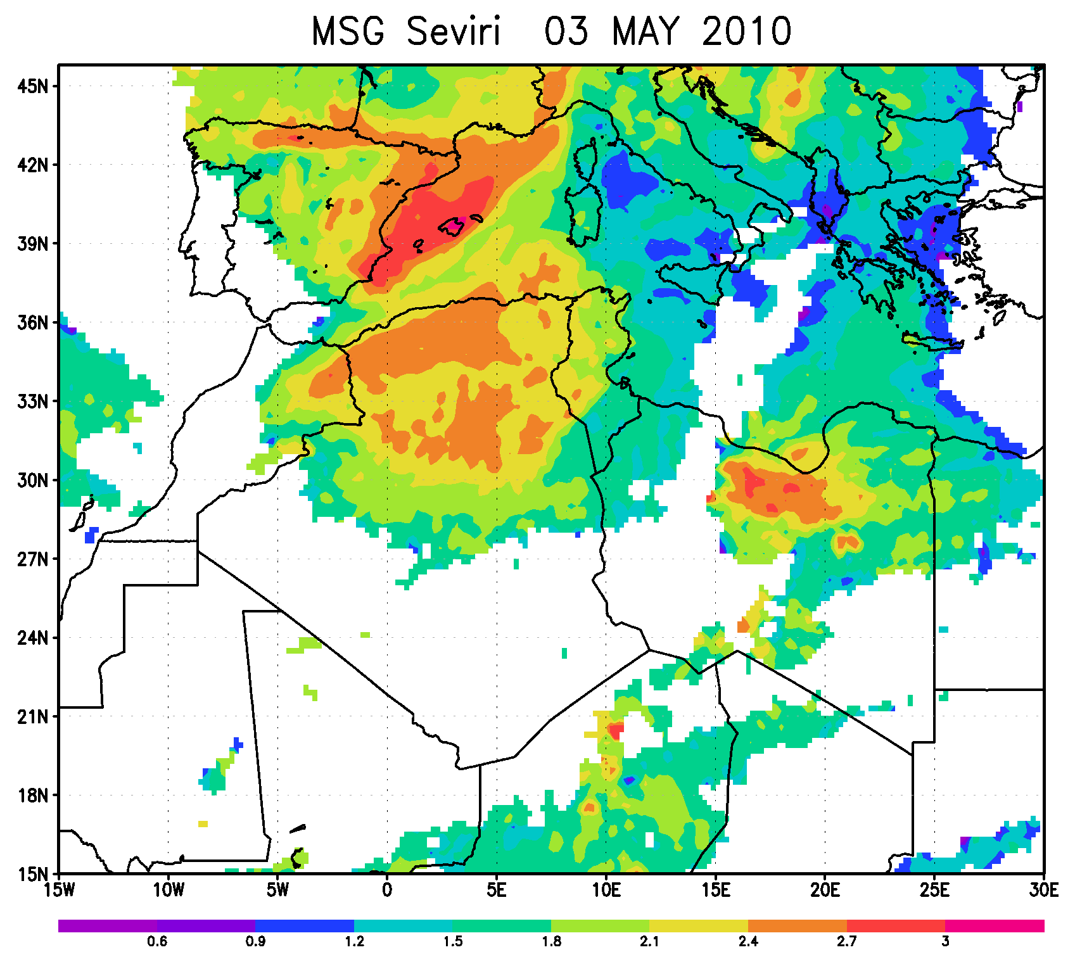
Model $\int{n_{IN}dz}$,; MSG-SEVIRI satellite ice water path
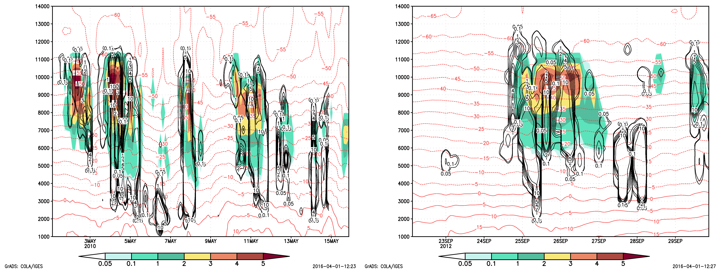
$\log_{10}$ (IWC ×${10}^{-6}\frac{kg}{m^{3}}$ obtained from Doppler radar reflectivity using Cloudnet algorithm (solid black line contour plot ) vs. DREAM $\log_{10}$ ($n_{IN}$) (colored contour plot), in the period 1-15 May 2010 (A), and 22-30 September 2012

We plan in 2017 to introduce operational prediction of ${ n}_{IN}$ in one of the NMMMB cloud schemes and to test the impacts of the is methodology on cloud and precipitation prediction. We also plan to provide the SEECOP community with ${ n}_{IN}$ gridded fields that the partners could use it in their NWP cloud schemes.

Prediction of flash floods by integrating the NMMB model and the HYPROM Hydrology Prediction Model
(See more in Hydrology predictions in the next Section)

- SEECOP Activities Plan 2016-2021
According to the SEECOP Agreement, a number of activities shall be carried out within the Consortium. Activities based on specific objectives as specified in document will in general include different NWP activities such as: Data assimilation and use of observations; Diagnostics, validation and verification; Aspects of modelling implementation and operations; Specific NWP-related applications driven by NMMB; Technical aspects such as automatic execution procedures and graphical interpretation; Training.
Model validation; Case studies
To determine the value of weather forecasts, we need to measure it against the observed state of the atmosphere. In many cased forecasts perform well according to standard skill scores (RMS, bias, correlation) used for verification, but sometimes do not fulfill users expectations. Following the recommendations of WMO, conventional skill scores will be complemented with those developed to satisfy some specific user needs. SEECOP will also work on introducing this specific category of verification scores such as: Methods for dichotomous (yes/no) forecasts based on contingency tables (usually used for precipitation; Threat score for precipitation; Object oriented scores (contiguous rain areas method where rainfall patterns are validated by considering location, volume, and pattern errors).
An additional tool to better understand behavior of the Consortium prognostic model will be performing model experiments for series of specific atmospheric, preferably high impact weather, cases such as: torrential rains, heat waves, extreme wind conditions, surface icing, fog, etc. For this purpose, an inventory of cases accompanied with as much as possible observational data of different kinds will be established. SEECOP Members will be encouraged to participate in models executions and corresponding intercomparisons for selected cases.
Training workshops
During the mid-term period, 2-3 workshops on different NWP issues would be organized. The first Workshop planned for 2017 would be devoted to hands-on training on use of the NMMB prognostic system. Later workshops could be addressed to subjects such as data assimilation, validation/case studies or other issues of common interest.
Data assimilation, model aspects
Most of the current atmospheric models used by the Consortium members is based on the ready external global model products (such as ECMWF, NCEP) used for specifying initial conditions of the operational model executions. Such approach is a reasonable choice if there is no added a component for assimilation of meteorological observations. However, in order to further increase the accuracy of NWP data assimilation should be included to determine a best possible atmospheric state using observations and short range forecasts. Data assimilation is typically a sequential time-stepping procedure, in which a previous model forecast is compared with newly received observations, the model state is then updated to reflect the observations, a new forecast is initiated, and so on. The update step in this process is usually referred to as the analysis; the short model forecast used to produce the analysis is called the background.
First attempts to add data assimilation into NMMB system has been already performed in RHMSS. It is based on the GISS NCEP Kalman filtering approach which uses satellite observations. Another Kalman filter approach developed by the Deutscher Wetterdienst (DWD) will be also implemented and tested. Both schemes will extensively tested and validated in sensitivity experiments by the end of 2017. Data assimilation, mentioned above or assimilations of other types, will be introduced in the mid-term period, using different observations (conventional measurements, radars, satellites, etc) by Members whose computational and man-power resources could support this task.
The Consortium Members should work on developing a common software for 1- and 2-way model nesting, in order to provide very high resolution NMMB downscaling. First results in performing this mid-term task could be expected by the end of 2017. In the chain of nested models the key input would be use of the NMMB global version already run by RHMSS. During 2017, a regular global NMMB products would be available at a dedicated Consortium web page.

Surface conditions
Over the mid-term period, a new generation of high-resolution NMMB (estimated to approach 1km or less, down to ~100m for some applications) quasi-stationary geo data (such as land cover, soil types, topography, etc) should be introduced into the Consortium modelling system. Introduction of new geo data at the same time will be beneficial for NMMB model versions executed with coarser resolutions.
One of the soil parameters of extreme importance is soil wetness to be used to describe soil initial conditions in NMMB. Currently, this parameter is far from being sufficiently accurate, it is typically accepted as output from external (e.g. ECMWF) modelling systems. SEECOP will consider use of a satellite-based high-resolution observations of the surface soil moisture (a promising option would be future ESA Sentinel-1 measurements). Earth observation of near-surface soil moisture content is of tremendous scientific and application interest for understanding of the interactions between water, energy and biochemical fluxes, the forecasting of meteorological and hydrological events, crop yield predictions, etc.
NMMB aerosol transport component; aerosol-atmosphere interactions
The Dust Regional Atmospheric Model - DREAM (Nickovic et al, 20101; Pejanovic et al, 2011) has been implemented in 2011 within SEEVCCC to perform daily forecasts of the atmospheric dust transport driven for the moment with the NMME model. DREAM simulates the atmospheric cycle of mineral dust aerosol: dust emission, turbulent diffusion, vertical and horizontal advection, lateral diffusion, and wet and dry deposition. DREAM is the most widely used model worldwide applied for research and operational purposes in more 20 organizations, including those from Serbia, Montenegro, and the Former Yugoslav Republic of Macedonia . DREAM has been also used to forecast/simulate other types of aerosol: pollen, volcanic ash and sea salt.
The ongoing development in RHMSS is addressed to implement a parameterization scheme in NMM-DREAM model which takes into account dust-cloud interactions. Recent research namely clearly indicate that dust appears as a perfect natural cloud seeder responsible for ice nucleation in more than 60% cold clouds (Cziczo, 2013; Nickovic, et al, 2016). During 2016/2017, predicted ice nuclei (IN) concentration will be introduced into the NMMB Thompson cloud microphysics (Thompson and Eidhammer, 2014), replacing dust climatology used in the original Thompson code with the predicted dust and related predicted IN. During 2016/2017, predicted 3D ice nuclei (IN) concentration will be made publically available to the Consortium as input parameter to cloud microphysics schemes in the Partners' models.
During the mid-term period, the new method (indirect aerosol effect) will be extensively tested. It is expected that NMMB clouds and precipitation will be predicted more accurately. In addition, direct aerosol effects (aerosol-radiation interactions) will be also developed and implemented into NMMB operations.
Hydrology predictions
The HYPROM hydrology surface-runoff prognostic model (Nickovic et al, 2010; Pejanovic et al) has been developed to predict surface hydrology conditions. Currently, HYPROM is used in RHMSS to test its capabilities to forecast floods for several selected cases in the SEE region. The model has been developed to simulate overland watershed processes using the full dynamics numerical of the governing equation system. Since no major simplification of the governing system is used (such as e.g. a kinematic approximation), this permits representation of different hydrology scales ranging from short term processes (e.g. flash floods) to flows of large slow river watersheds. Unlike most current hydrology models, HYPROM does not requires its calibration against long discharge data over a particular river basin. HYPROM can be driven by precipitation from either an atmospheric model or from observed precipitation. Recently, HYPROM has been integrated within NMMB non-hydrostatic atmospheric model in a two-way coupled manner (Vujadinović, 2015).
During the mid-term period, HYPROM will be extensively tested for a series of torrential/flood cases in the region. Within the period, a user-based interface will be developed to provide simple setup of the model and its efficient execution of the model for a selected river basin. A water pollution component will be added to the model in order to predict surface and sub-surface transport of polluted substances. On a longer term, the integrated NMMB-HYPROM system should be run operationally in order to increase the accuracy of NWP to be achieved through the atmosphere-hydrology feedback mechanisms.
Consortium web site updates; Consortium outreach
During 2016, the Institute of Hydrometeorology and Seismology of Montenegro launched the Consortium web seecop.meteo.co.me. With assistance of all CEECOP members, the web site will be regularly updated with news, events and the Consortium documents. The web site will be thus a place to promote the SEECOOP activities. In addition, model data exchange will be also performed on the web server through a protected ftp server.
As a continuous task, promotion of SEECO will be performed through media news, social networks and through active collaboration with the EWGLAM C-SRNWP and participation in its activities.

References
Nickovic, S. G. Kallos, A. Papadopoulos, and O. Kakaliagou, 2001: A model for prediction of desert dust cycle in the atmosphere J. Geophys. Res. 106, 18113-18130.
Janjic, Z., 2009: Further development of the unified multiscale Eulerian model for a broad range of spatial and temporal scales within the new National Environmental Modeling System. Geophysical Research Abstracts, Vol. 11, EGU2009-1587, 2009, European Geosciences Union, General Assembly 19-24 April 2009, Vienna, Austria.
Janjic, Z. I., J. P. Gerrity, Jr. and S. Nickovic, 2001: An alternative approach to nonhydrostatic modeling. Mon. Wea. Rev., 129, 1164-1178.
Nickovic S., 2002, Towards integrated treatment of the Earth environment: Current and future modelling developments at ICoD. 18th International Conference on Carpathian Meteorology, 7-11 October 2002, Belgrade, Yugoslavia.
Pejanovic, G., S. Nickovic, M. Vujadinovic, A. Vukovic, V. Djurdjevic, M. Dacic, Atmospheric deposition of minerals in dust over the open ocean and possible consequences on climate. WCRP OSC Climate Research in Service to Society, 24-28 October 2011, Denver, CO, USA
Djurdjevic, V and Rajkovic, B., 2008, Verification of a coupled atmosphere-ocean model using satellite observations over the Adriatic Sea. Ann. Geophys., 26(7): 1935-1954, doi: 10.5194/angeo-26-1935-2008
Shukla, J., 2009, Seamless Prediction of Weather and Climate: A New Paradigm for Modeling and Prediction Research US National Oceanic and Atmospheric Administration. Climate Test Bed Joint Seminar Series
NCEP, Camp Springs, Maryland, 10 February 2009
Nickovic, S., Cvetkovic, B., Madonna, F., Pejanovic, G., Petkovic, S., and Nikolic, J.: Predicting cloud ice nucleation caused by atmospheric mineral dust, Atmos. Chem. Phys. Discuss., doi:10.5194/acp-2016-393, in review, 2016.
Cziczo, J.D., K. D. Froyd, C. Hoose, E.J. Jensen, M. Diao, M.A. Zondlo, J.B. Smith, C.H. Twohy, D.M. Murphy, 2013: Clarifying the Dominant Sources and Mechanisms of Cirrus Cloud Formation Science14 Jun 2013 : 1320-1324
Thompson, G. and T.Eidhammer, 2014: A Study of Aerosol Impacts on Clouds and Precipitation Development in a Large Winter Cyclone. J. Atmos. Sci., 71, 3636–3658.
Vujadinovic M., 2015: Modeling of the hydrological cycle in the integrated geophysical system, PhD thesis, Faculty of Physics, University of Belgrade.
Spiridonov V., M. Ćurić, 2016: Examination of physical processes of convective cell evolved from a MCS - using a different model initialization. Asia-Pacific Journal of Atmospheric Sciences, 1-17.
Hunt, et, all, 2007: Efficient data assimilation for spatiotemporal chaos: A local ensembletransform Kalman filter. Physica D, 230, 112-126,doi:10.1016/j.physd.2006.11.008.
Janjic Z. and R. L. Gall 2012., Scientific documentation of the NCEP nonhydrostatic multiscale model on the B grid (NMMB). Part I Dynamics. NCAR Technical Note NCAR/TN-489+STR, doi: 10.5065/D6WH2MYX
Janjic Z. et. All. 2014: NMM version 3 modeling system user's guide. http://www.dtcenter.org/wrf-nmm/users/docs/user_guide/V3/users_guide_nmm_chap1-7.pdf
Kasic, 2016., LETKF-NMMB, Ensemble based system for regional dana assimilation. Workshop on „Probabilistic Prediction of Severe Weather Phenomena“, Bologna 17-19 Maj 2016. https://drive.google.com/folderview?id=0B2VKfs850rr-Y1dBYVd4UmxjRk0&usp=drive_web
Atkinson, J. D., Murray, B. J., Woodhouse, M. T., Whale, T. F.,Baustian, K. J., Carslaw, K. S., Dobbie, S., O’Sullivan, D., andMalkin, T. L.: The importance of feldspar for ice nucleation bymineral dust in mixed-phase clouds, Nature, 498, 355–358, 2013.
DeMott, P. J., Prenni, A. J., McMeeking, G. R., Sullivan, R. C., Petters, M. D., Tobo, Y., Niemand, M., Möhler, O., Snider, J. R., Wang, Z., and Kreidenweis, S. M.: Integrating laboratory and field data to quantify the immersion freezing ice nucleation activity of mineral dust particles, Atmos. Chem. Phys., 15, 393-409, doi:10.5194/acp-15-393-2015, 2015.
Cziczo, D. J., and K. D. Froyd, 2014: Sampling the composition of cirrus ice residuals. Atmos.Res., 142, 15 – 31, doi:10.1016/j.atmosres.2013.06.012.
Thompson, G and T.Eidhammer, 2014: A Study of Aerosol Impacts on Clouds and Precipitation Development in a Large Winter Cyclone. J. Atmos. Sci., 71, 3636–3658.
Nickovic, S., Cvetkovic, B., Madonna, F., Pejanovic, G., Petkovic, S., and Nikolic, J.: Predicting cloud ice nucleation caused by atmospheric mineral dust, Atmos. Chem. Phys. Discuss., doi:10.5194/acp-2016-393, in review, 2016.
APPENDIX

NMMB model
The NCEP Nonhydrostatic Multiscale Model on the B grid (NMMB) (Janjic, 2005; Janjic and Black, 2007; Janjic et al., 2011) has been designed for a broad range of spatial and temporal scales and follows the general modeling philosophy of the NCEP’s WRF NMM grid-point dynamical core (Janjic et al., 2001; Janjic, 2003). However, in contrast to the WRF NMM that uses the Arakawa E grid, the NMMB was reformulated for the Arakawa B grid. The NMMB uses the regular latitude-longitude grid for the global domain, and rotated latitude-longitude grid in regional applications. The nonhydrostatic component of the model dynamics is introduced through an add–on module so that it can be turned on or off depending on resolution.
In the model, “isotropic” finite-volume horizontal differencing is employed that conserves a variety of basic and derived dynamical and quadratic quantities and preserves some important properties of differential operators. The second order energy and enstrophy conserving scheme is used for horizontal advection of momentum, but a fourth order scheme that turned out to be the best in nonlinear tests (Janjic et al., 2011) is available as an option, too. The conservation of energy and enstrophy by the second order scheme, and the experimentally demonstrated control over the nonlinear energy cascade by the fourth order scheme, improve the accuracy of the nonlinear dynamics of the model on all scales, and render the model suitable for extended integrations without excessive dissipation.
Conservative polar boundary conditions are specified in the global limit. The polar filter selectively reduces tendencies of the wave components of the basic dynamical variables that would otherwise propagate faster in the zonal direction than the fastest wave propagating in the meridional direction.
In the vertical, the hybrid pressure-sigma coordinate is used (Simmons and Burridge, 1981; Eckerman, 2009). The forward-backward scheme (Janjic, 1979) is employed for horizontally propagating fast waves, and an implicit scheme is used for vertically propagating sound waves.
Slightly off-centered Adams-Bashforth scheme is applied for non-split horizontal advection of the basic dynamical variables and for the Coriolis force (Janjic et al., 2001; Janjic, 2003). Instead of being slightly unstable, due to off-centering, the scheme becomes weakly dissipative. Even though the instability of the second-order Adams-Bashforth scheme is very weak, and can be tolerated in practice, the weakly damping off-centered scheme is preferred since strictly speaking unstable schemes do not converge. Even though the off-centered scheme is formally of the first order accuracy, the actual magnitude of its truncation error remains close to that of the second-order Adams-Bashforth scheme due to very small off-centering.
On the B/E semi-staggered grids the advection time step can be only about twice longer than the forward-backward adjustment time step because longer time steps can be used for the adjustment terms than on the C grid. So the Adams-Bashforth scheme for advection with the same time step as that used for the adjustment terms costs the same as a two-step iterative scheme with twice longer time step. Moreover, since there is no time splitting, there is no need for iterating the adjustment terms, and the short time steps reduce the time stepping errors. So, non-iterative, non-split Adams-Bashforth scheme offers significant savings, and at the same time its short time step reduces numerical errors.
In order to eliminate computational stability problems due to thin vertical layers, the Crank-Nicholson scheme is used to compute the contributions of vertical advection. As a compromise between requirements for computational affordability and accuracy, a fast Eulerian conservative and positive definite scheme was developed for model tracers (Janjic et al., 2009). Conservative monotonization is applied in order to control over-steepening within the conservative and positive definite tracer advection step.
A variety of physical parameterizations have been coupled to the model. This variety will be further extended within the NOAA Environmental Modeling System (NEMS). The standard operational, and thoroughly tested in NWP and regional climate applications physical package includes the nonsingular Mellor-Yamada-Janjic (MYJ) level 2.5 turbulence closure for the treatment of turbulence in the planetary boundary layer (PBL) and in the free atmosphere (Janjic, 2001), the surface layer scheme based on the Monin-Obukhov similarity theory (Monin and Obukhov, 1954) with viscous sub-layer over land and water (Zilitinkevich, 1965; Janjic´, 1994), the NCEP NOAH land surface model (Ek et al., 2003) or the LISS model by Janjic (Vukovic et al., 2010), the GFDL long- wave and shortwave radiation (Fels and Schwarzkopf, 1975; Lacis and Hansen, 1974), the Ferrier grid-scale clouds and microphysics (Ferrier et al., 2002), the Betts-Miller-Janjic convection scheme (Betts, 1986; Betts and Miller, 1986; Janjic´, 1994, 2000). The lateral diffusion is formulated following the Smagorinsky nonlinear approach (Janjic´, 1990). Additionally, the RRTM radiation (Mlawer et al., 1997) with aerosol capability has been coupled to the NMMB model.
As can be seen from the brief model description given above, the NMMB satisfies all the requirements for regional climate research set up by the SEEVCCC, and therefore represents a good choice for the driving atmospheric model of the SEEVCCC Earth modeling system. Namely,
- The NMMB covers multiple spatial scales, from meso to global
  - It is nonhydrostatic (on the small scale end)
  - It is global (on the large scale end)
- The NMMB is suitable for extended integrations
  - It is quadratic conservative
  - It has sufficiently accurate conservative, positive definite and monotone tracer transport
  - It allows use of minimal non-physical dissipation
- The standard NMMB physics converges with resolution
- The NMMB radiation formulation is capable of interacting with particulate and gaseous aerosols
- The NMMB turbulence closure is physically well founded
- The NMMB moist processes (grid scale and convection) are capable of interacting with aerosols and radiation
- The NMMB is computationally efficient and scalable

Even though the NMMB is currently a state-of-the-art atmospheric model, its ongoing support by the NCEP and other partners will ensure that it will remain up to date. The continuous development of atmospheric models is necessary.
While model dynamics typically do not change much over time, the model physics are subject to more frequent changes. For example, the atmosphere exchanges large portion of its energy through the Earth surface, which renders the treatment of surface processes very important.

SEEVCCC, hosted by Republic Hydrometeorological Service of Serbia (RHMSS), brings together scientists in climate research and operations in order to perform development and operational functions for climate monitoring, long range forecast, monthly forecast. R&D and operational activities are based on products from numerical modeling of the integrated Earth system, and their applications in agriculture, forestry, energetics and environment.
the National Meteorological and Hydrological Services (NM(H)Ss) of the following WMO Member States: the Republic of Albania, the Federation of Bosnia and Herzegovina (Bosnia and Herzegovina), the Republic of Srpska (Bosnia and Herzegovina), the Former Yugoslav Republic of Macedonia , Montenegro and the Republic of Serbia.
National Centers for Environmental Prediction, USA
A good part of this section has been accepted from http://www.nws.noaa.gov/ost/climate/STIP/FY09CTBSeminars/shukla_021009.pdf. This paper describes the concept of seamless prediction and its evolution during the establishment of the COPES (Coordinated Observation and Prediction of the Earth System) framework of the World Climate Research Program (WCRP), where the concept was first presented in 2005.

